Hook and Exit Plugins

Pre Login Action in liferay

* create an Activator Module Project with the Project Template of "activator"
* after creating the Module Right Click on the module to create a component class

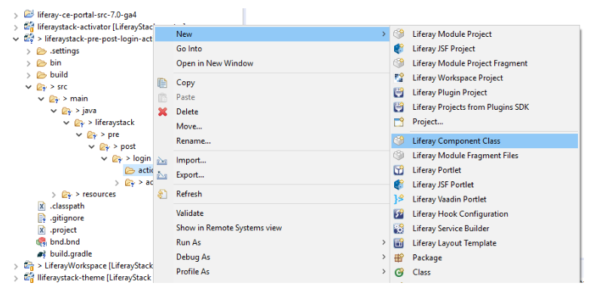

* Select the "Login Pre Action" component class template and give a component class name

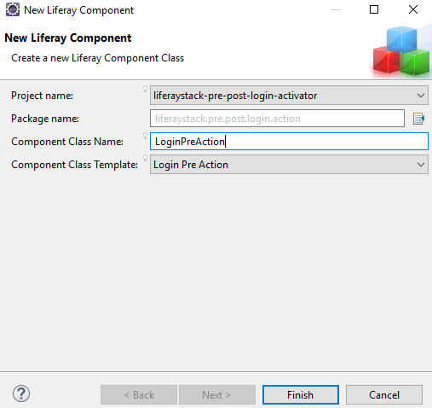

* After creating the component you will be able to see the LoginPreAction Class.

package liferaystack.pre.post.login.action;

import com.liferay.portal.kernel.events.ActionException;

import com.liferay.portal.kernel.events.LifecycleAction;

import com.liferay.portal.kernel.events.LifecycleEvent;

import com.liferay.portal.kernel.exception.PortalException;

import com.liferay.portal.kernel.util.PortalUtil;

import javax.servlet.http.HttpServletRequest;

import org.osgi.service.component.annotations.Component;

@Component(

immediate = true,

property = {

"key=login.events.pre"

},

service = LifecycleAction.class

)

public class LoginPreAction implements LifecycleAction {

@Override

public void processLifecycleEvent(LifecycleEvent lifecycleEvent)

throws ActionException {

HttpServletRequest request = lifecycleEvent.getRequest();

long userId = 0;

try {

userId = PortalUtil.getUser(request).getUserId();

} catch (PortalException e) {

e.printStackTrace();

}

System.out.println("login.event.pre, userId : " +userId);

}

}

**Post Login Action**

For Post Login Action the property key will be **"key=login.events.post"**

package liferaystack.pre.post.login.action;

import com.liferay.portal.kernel.events.ActionException;

import com.liferay.portal.kernel.events.LifecycleAction;

import com.liferay.portal.kernel.events.LifecycleEvent;

import com.liferay.portal.kernel.exception.PortalException;

import com.liferay.portal.kernel.util.PortalUtil;

import javax.servlet.http.HttpServletRequest;

import org.osgi.service.component.annotations.Component;

@Component(

immediate = true,

property = {

"key=login.events.post"

},

service = LifecycleAction.class

)

public class LoginPostAction implements LifecycleAction {

@Override

public void processLifecycleEvent(LifecycleEvent lifecycleEvent)

throws ActionException {

long userId = 0;

HttpServletRequest request = lifecycleEvent.getRequest();

try {

userId = PortalUtil.getUser(request).getUserId();

} catch (PortalException e) {

e.printStackTrace();

}

System.out.println("login.event.post, userId : " +userId);

}

}

buil.gradle

dependencies {

compileOnly group: "org.osgi", name: "org.osgi.core", version: "6.0.0"

compile group: "org.osgi", name:"org.osgi.service.component.annotations", version:"1.3.0"

compileOnly group: "com.liferay.portal", name: "com.liferay.portal.kernel", version: "2.0.0"

compileOnly group: "javax.servlet", name: "javax.servlet-api", version: "3.0.1"

compileOnly group: "javax.portlet", name: "portlet-api", version: "2.0"

compileOnly group: "com.liferay.portal", name: "com.liferay.util.taglib", version: "2.0.0"

compileOnly group: "jstl", name: "jstl", version: "1.2"

compileOnly group: "org.osgi", name: "osgi.cmpn", version: "6.0.0"

}